Assignment 3

Camera Calibration and Augmented Reality

bf289

* **Part1 Camera Calibration using 3D calibration object** 
  1. A close up of a map

     Description automatically generated
  2. A screenshot of text

     Description automatically generated
  3. A screenshot of a cell phone

     Description automatically generatedA screenshot of a cell phone

     Description automatically generated
  4. A screenshot of a cell phone

     Description automatically generated
  5. A close up of a logo

     Description automatically generated
  6. 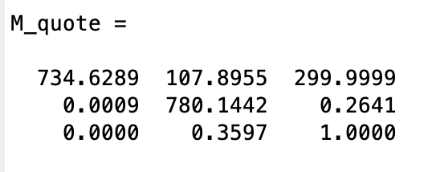
  7. A screenshot of a cell phone

     Description automatically generated
  8. 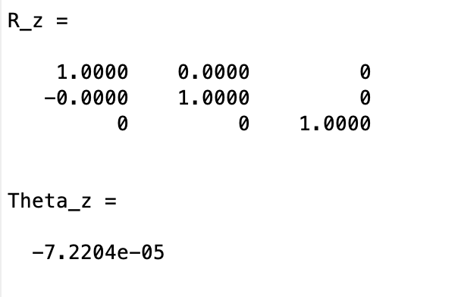
  9. A screenshot of a cell phone

     Description automatically generated
* **Part2 Camera Calibration using 2D calibration object**

1. Corner Extraction and Homography computation

1. Computing the Intrinsic and Extrinsic parameters

|  |  |
| --- | --- |
| B_matrix |  |
| v_0 |  |
| lambda |  |
| alpha |  |
| beta |  |
| gamma |  |
| u_0 |  |
| A_matrix |  |
|  |  |
|  |  |
|  |  |
|  |  |

1. Improving accuracy

Projected grid corners

|  |  |
| --- | --- |
|  |  |
|  |  |

Harris corners

|  |  |
| --- | --- |
|  |  |
|  |  |

Closest harris corners

|  |  |
| --- | --- |
|  |  |
|  |  |

H matrix

K matrix

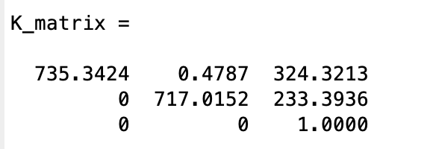

R and T matrix

|  |  |
| --- | --- |
|  |  |
|  |  |

Err_reprojection

|  |
| --- |
|  |
|  |
|  |
|  |

* **Part3 Augmented Reality 101**

Augment an Image

|  |  |
| --- | --- |
|  |  |
|  |  |

Augment an Object

|  |  |
| --- | --- |
|  |  |
|  |  |

* **Extra Credit**

We could estimate the intrinsic and extrinsic parameters from only two images of the grid as Zhang described in the section 2.4.9:

Let (Rs, ts) be the rigid transformation between the two cameras such that

or more precisely R’=RRs and t’=Rts+t.

Stereo calibration is then to solve A,A’,k1,k2,k1’,k2’,{(Ri,ti)|i = 1,…,n}, and (Rs, ts) by minimizing the following functions:

subject to

Obviously, it is a nonlinear optimization problem. To obtain the initial guess, we first run single-camera calibration independently for each camera, and compute Rs through SVD from and ts through least-squares from .